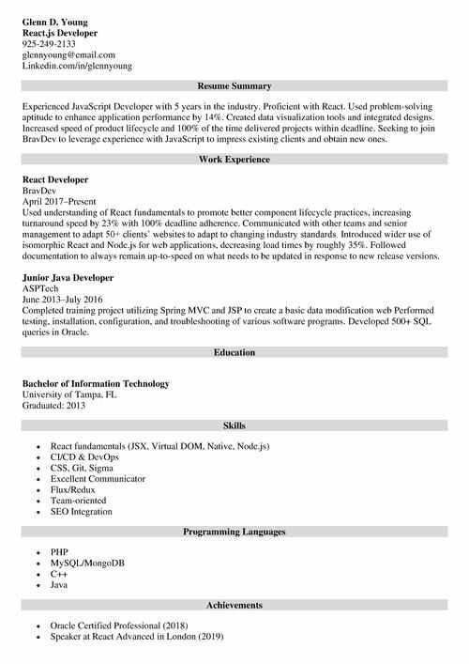
Glenn D. Young React.js Developer 925-249-2133
glennyoung@email.com
Linkedin.com/in/glennyoung
Resume Summary
Experienced JavaScript Developer with 5 years in the industry. Proficient with React. Used problem-solving aptitude to enhance application performance by 14%. Created data visualization tools and integrated designs. Increased speed of product lifecycle and 100% of the time delivered projects within deadline, Seeking to join Brav Dey to leverage experience with JavaScript to impress existing clients and obtain new ones.
React Developer BravDev
Work Experience
April 2017-Present
Used understanding of React fundamentals to promote better component lifecycle practices, increasing turnaround speed by 23% with 100% deadline adherence. Communicated with other teams and senior management to adapt 50+ clients websites to adapt to changing industry standards. Introduced wider use of isomorphic React and Node.js for web applications, decreasing load times by roughly 35%. Followed documentation to always remain up-to-speed on what needs to be updated in response to new release versions.
Junior Java Developer
ASPTech
June 2013-July 2016
Completed training project utilizing Spring MVC and JSP to create a basic data modification web Performed testing, installation, configuration, and troubleshooting of various software programs. Developed 500+ SQL queries in Oracle.
Bachelor of Information Technology
University of Tampa, FL
Graduated: 2013
Education
Skills
⚫ React fundamentals (JSX. Virtual DOM. Native. Node.js)
CI/CD & DevOps
CSS, Git. Sigma
Excellent Communicator
Flux/Redux
Team-oriented
SEO Integration
MySQL/MongoDB
.PHP
CH
Java
Programming Languages
Achievements
Oracle Certified Professional (2018) Speaker at React Advanced in London (2019)

